**React Practice**

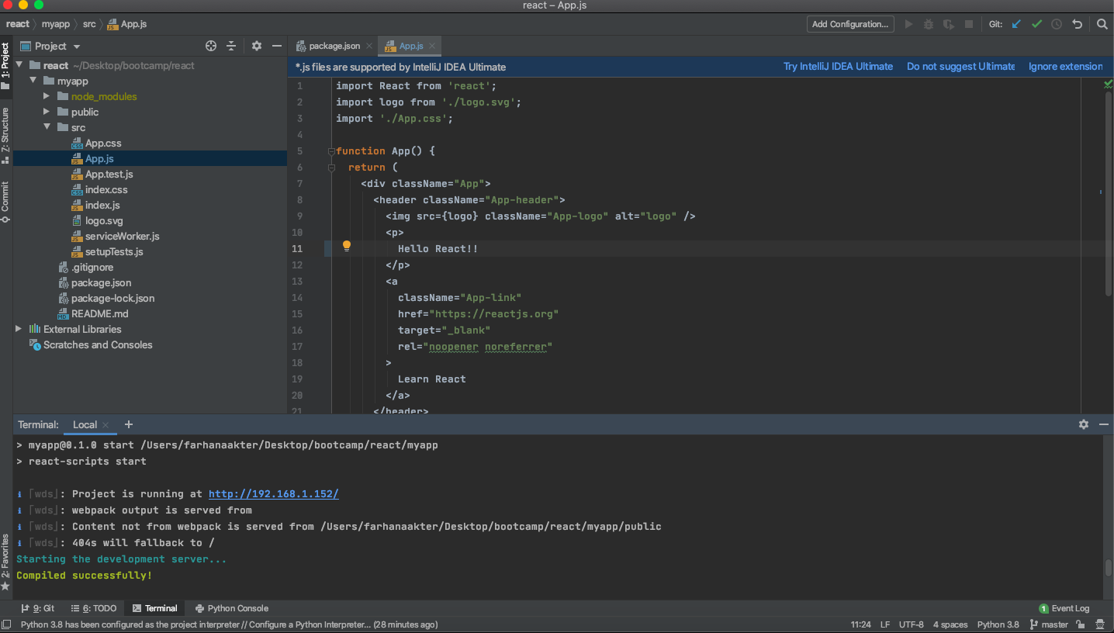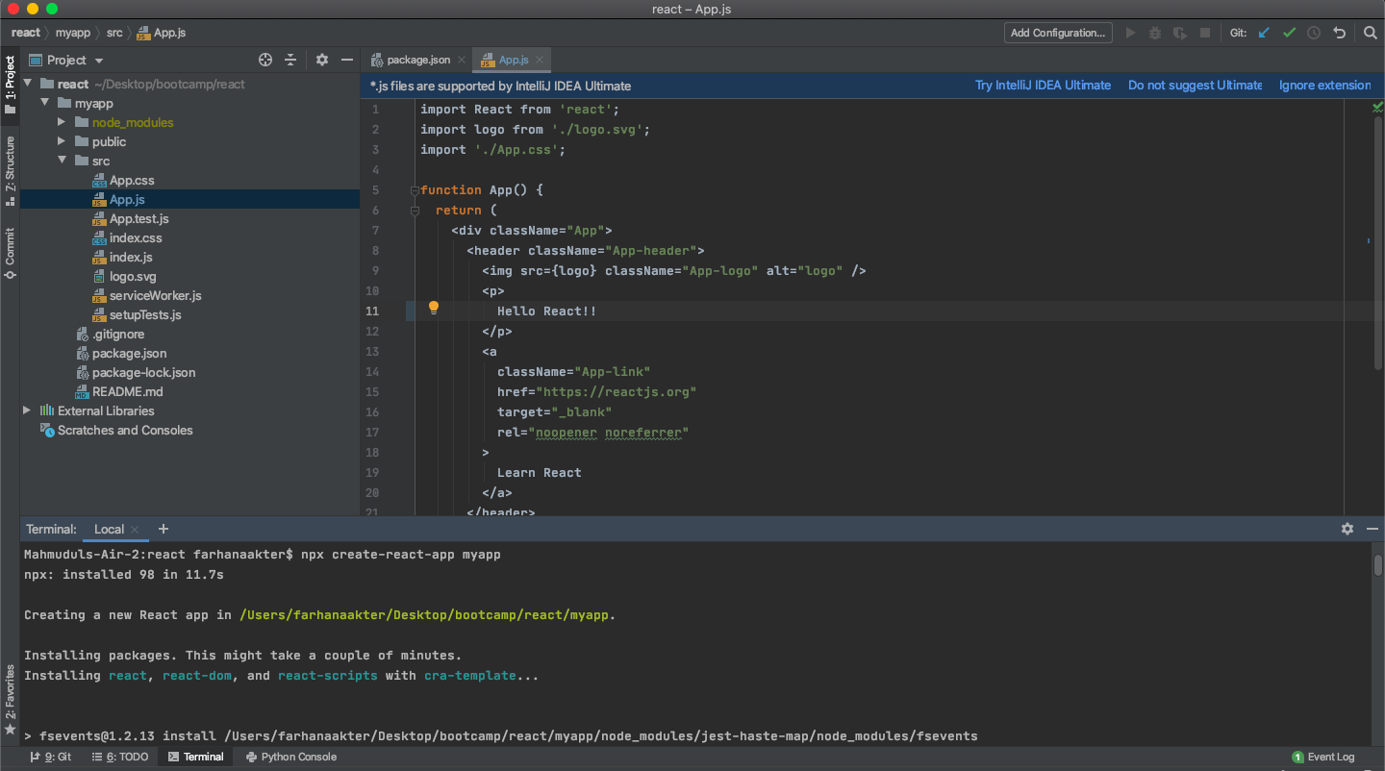

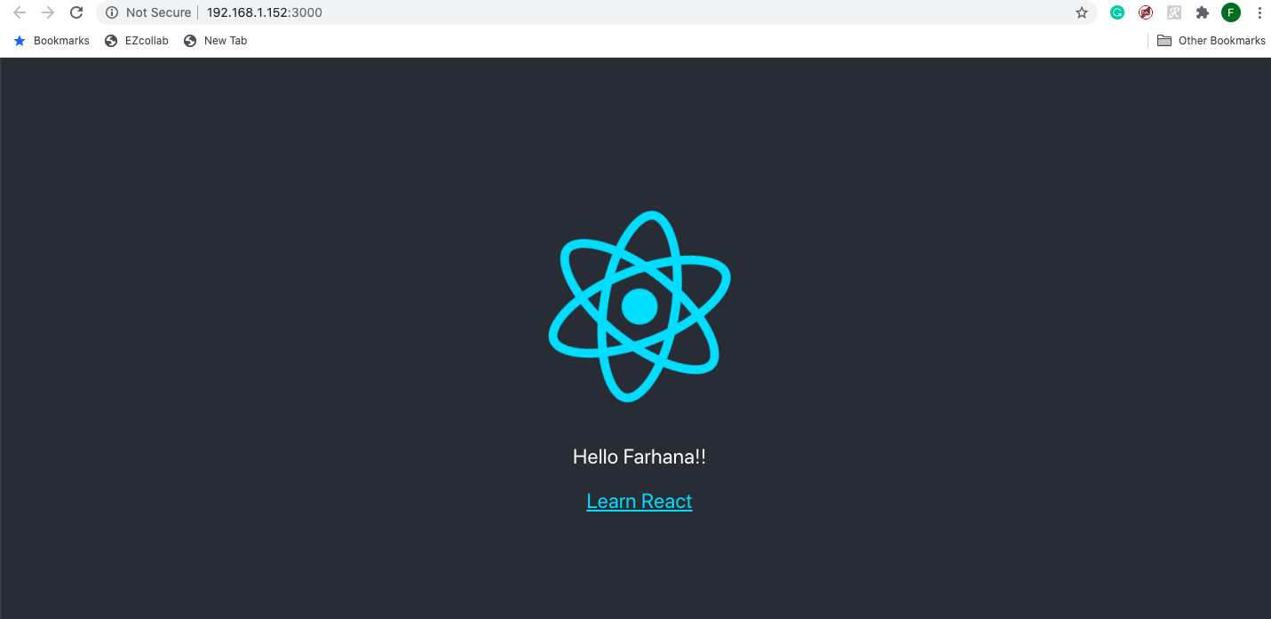

Command for React using Pycharm:

conda deactivate

ls

clear

ls

npx create-react-app myapp

ls

cd myapp

ls

npm start

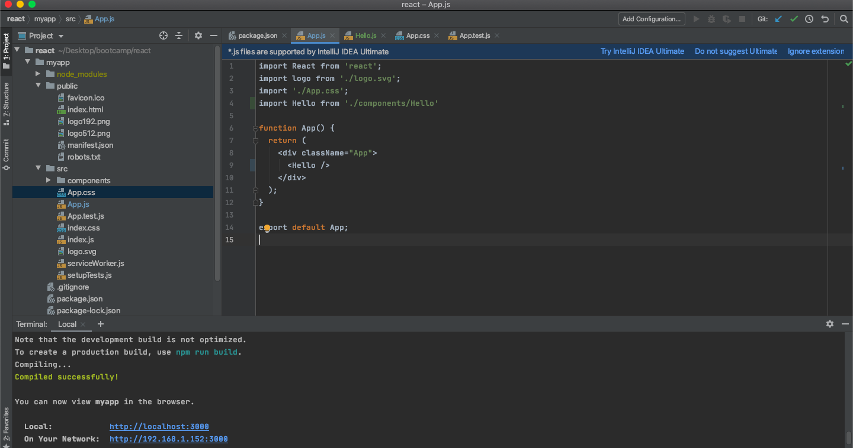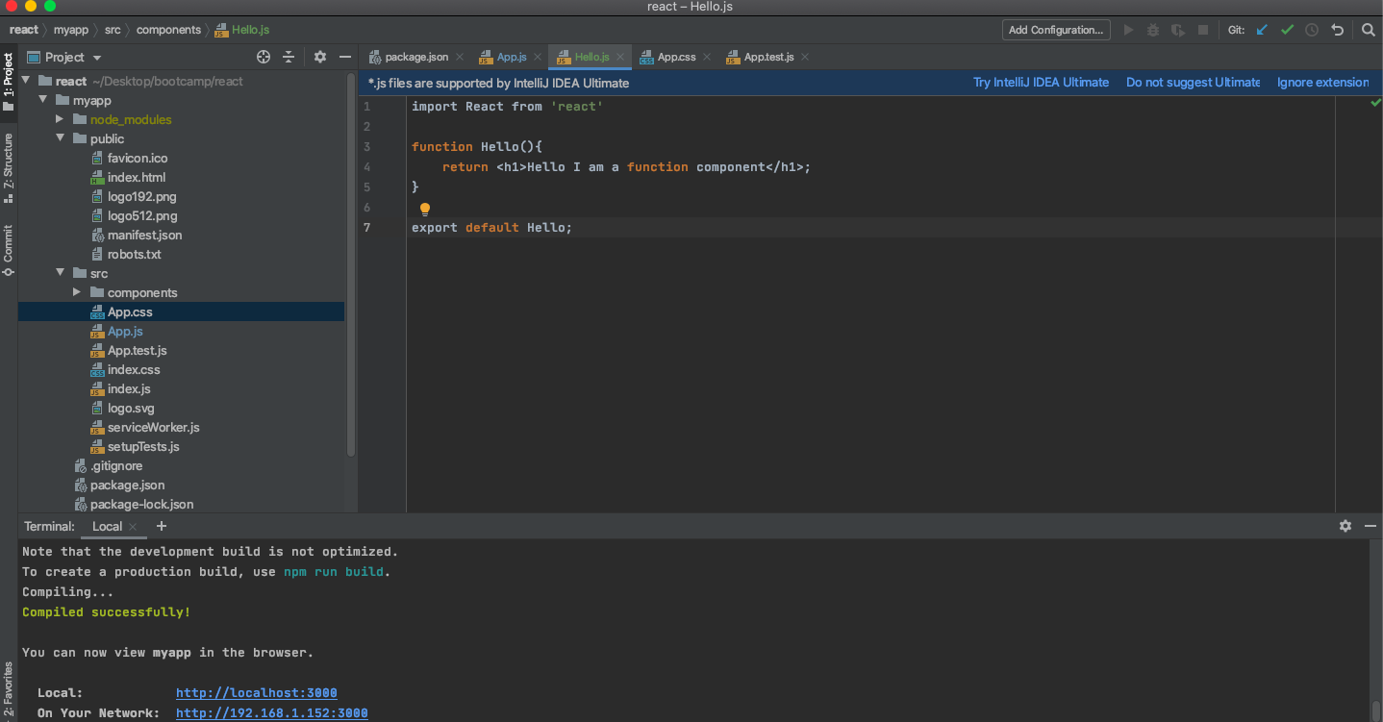

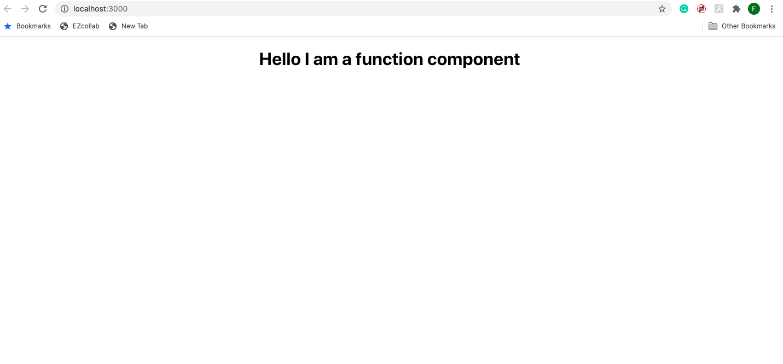

Command on Hello.js file under components directory::

const Hello = () => {}

const Hello = () => <h1>Hello I am function</h1>;

React Directly in HTML

The quickest way start learning React is to write React directly in your HTML files.

Start by including three scripts, the first two let us write React code in our JavaScripts, and the third, Babel, allows us to write JSX syntax and ES6 in older browsers.

You will learn more about JSX in the [React JSX chapter](https://www.w3schools.com/react/react_jsx.asp).

Example

Include three CDN's in your HTML file:

<!DOCTYPE html>

<html>

<script src="https://unpkg.com/react@16/umd/react.production.min.js"></script>

<script src="https://unpkg.com/react-dom@16/umd/react-dom.production.min.js"></script>

<script src="https://unpkg.com/babel-standalone@6.15.0/babel.min.js"></script>

<body>

<div id="mydiv"></div>

<script type="text/babel">

class Hello extends React.Component {

render() {

return <h1>Hello World!</h1>

}

}

ReactDOM.render(<Hello />, document.getElementById('mydiv'))

</script>

</body>

</html>

Setting up a React Environment

If you have NPM and Node.js installed, you can create a React application by first installing the create-react-app.

If you've already created the create-react-app you can skip this section.

Install create-react-app by running this command in your terminal:

C:\Users*Your Name*>npm install -g create-react-app

Then you are able to create a React application, let's create one called myfirstreact.

Run this command to create a React application named myfirstreact:

C:\Users*Your Name*>npx create-react-app myfirstreact

The create-react-app will set up everything you need to run a React application.

Run the React Application

Now you are ready to run your first *real* React application!

Run this command to move to the myfirstreact directory:

C:\Users*Your Name*>cd myfirstreact

Run this command to run the React application myfirstreact:

C:\Users*Your Name*\myfirstreact>npm start

A new browser window will pop up with your newly created React App! If not, open your browser and type localhost:3000 in the address bar.

The result:

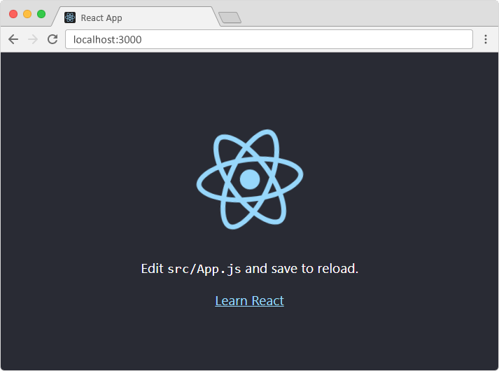

Modify the React Application

So far so good, but how do I change the content?

Look in the myfirstreact directory, and you will find a src folder. Inside the src folder there is a file called App.js, open it and it will look like this:

/myfirstreact/src/App.js:

import React, { Component } from 'react';

import logo from './logo.svg';

import './App.css';

class App extends Component {

render() {

return (

<div className="App">

<header className="App-header">

<img src={logo} className="App-logo" alt="logo" />

<p>

Edit <code>src/App.js</code> and save to reload.

</p>

<a

className="App-link"

href="https://reactjs.org"

target="_blank"

rel="noopener noreferrer"

>

Learn React

</a>

</header>

</div>

);

}

}

export default App;

Try changing the HTML content and save the file.

Notice that the changes is visible immediately after you save the file, you do not have to reload the browser!

Example

Replace all the content inside the <div className="App"> with a <h1> element.

See the changes in the browser when you click Save.

import React, { Component } from 'react';

class App extends Component {

render() {

return (

<div className="App">

<h1>Hello World!</h1>

</div>

);

}

}

export default App;

Notice that we have removed the imports we do not need (logo.svg and App.css).

The result:

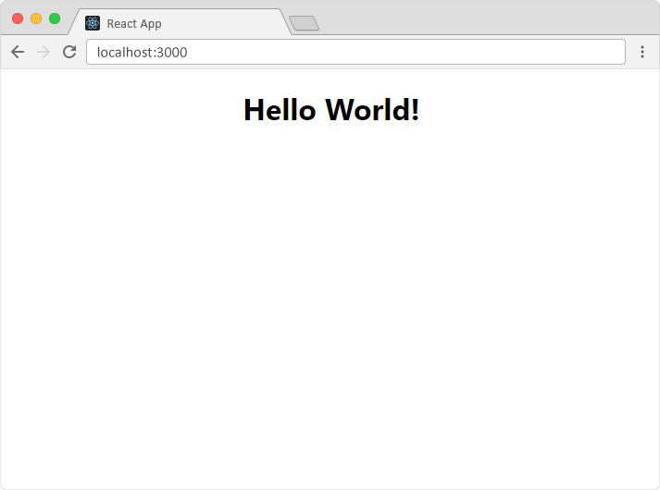

What's Next?

Now you have a React Environment on your computer, and you are ready to learn more about React.

In the rest of this tutorial we will use our Show React tool to explain the various aspects of React, and how they are displayed in the browser.

If you want to follow the same steps on your computer, start by stripping down the src folder to only contain two files: index.js and index.html, in some builds you might find the index.html in the public folder instead, you should also remove any unnecessary lines of code inside the two files to make them look like the files in the Show React tool below:

Example

Click the "Run Example" button to see the result.

index.js:

import React from 'react';

import ReactDOM from 'react-dom';

const myfirstelement = <h1>Hello React!</h1>

ReactDOM.render(myfirstelement, document.getElementById('root'));

index.html:

<!DOCTYPE html>

<html lang="en">

<head>

<meta charset="utf-8" />

<meta name="viewport" content="width=device-width, initial-scale=1" />

<title>React App</title>

</head>

<body>

<div id="root"></div>

</body>

</html>

[Run Example »](https://www.w3schools.com/react/showreact.asp?filename=demo2_react1)